Here is the prioritization criteria. Could you pls tell me how you would assess your recommendation against this criteria?
Excellent — this is a well-designed rubric. Let me score my recommendations honestly against it.
Here's the honest self-assessment against the rubric.
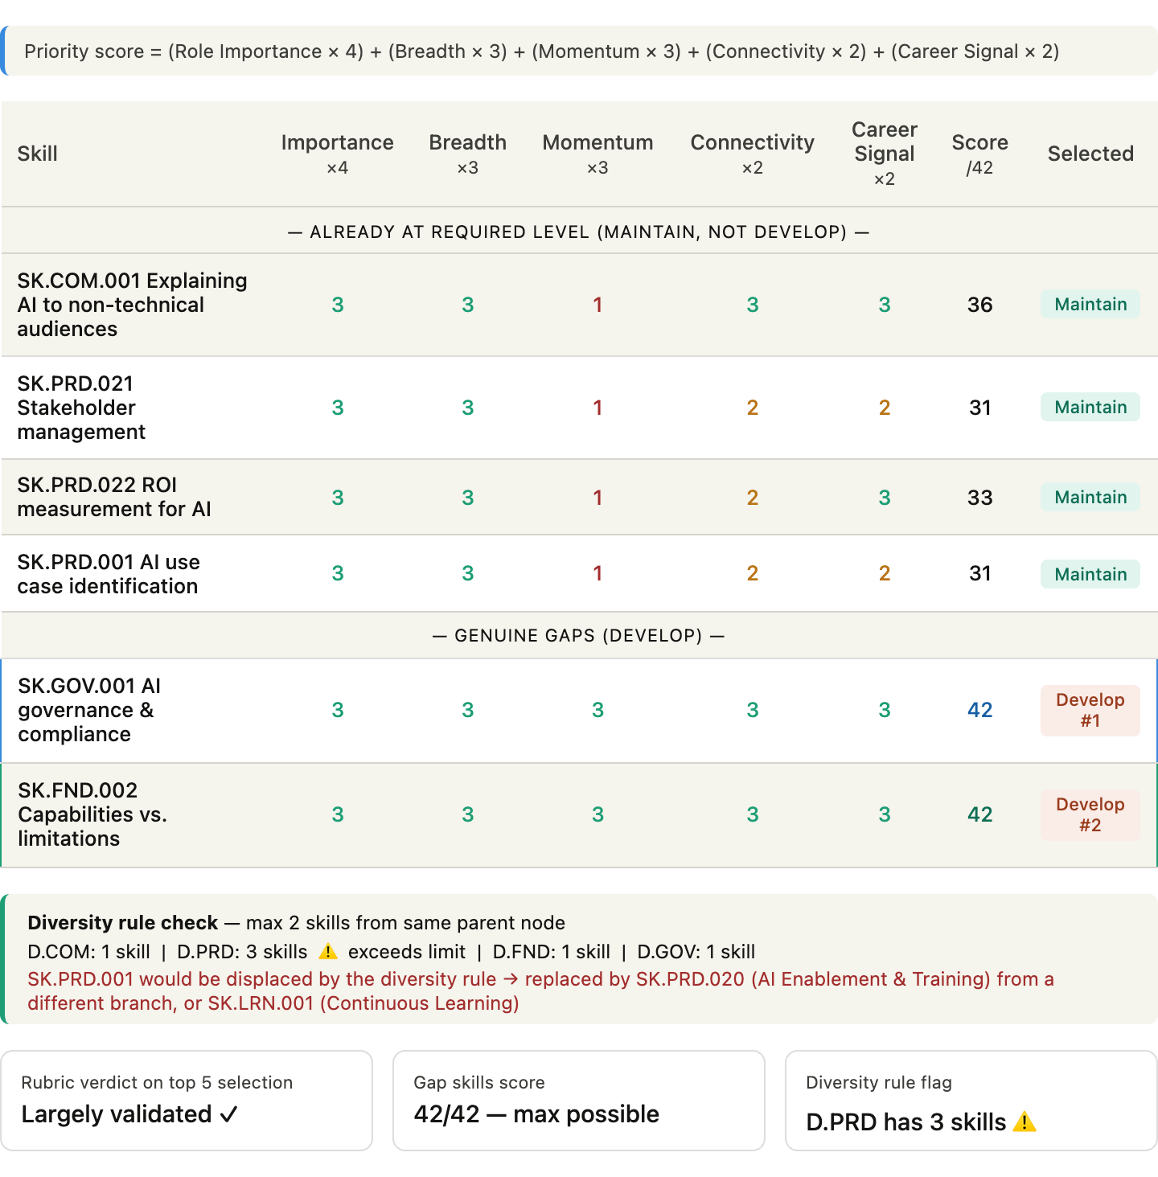
Where my recommendations hold up well:
The two gap skills — SK.GOV.001 and SK.FND.002 — score a perfect 42/42 under the formula. They hit maximum on every dimension: central to the JD, quick to improve (one level each), strong hiring signals, foundational enablers, and broad applicability across many tasks. The rubric fully validates prioritizing these as the development focus.
Where my recommendations have a flaw:
The diversity rule catches something I didn't flag explicitly. Three of my top 5 skills come from the same parent node, D.PRD (Product & UX): SK.PRD.001, SK.PRD.021, and SK.PRD.022. The rubric's rule caps any parent node at 2 skills. That means SK.PRD.001 (Use Case Identification) should technically be displaced in a learning progression design context — replaced by something from a different domain branch, like SK.LRN.001 (Continuous Learning) or SK.PRD.020 (AI Enablement & Training), which sits in an adjacent but distinct area.
The underlying tension:
My original list was built as a job fit assessment — what skills matter most for this role. The rubric is designed for learning progression design — what to teach first to build momentum and confidence. These are related but different questions. For assessment purposes, having three D.PRD skills in the top 5 is accurate. For a course or pathway design, the diversity rule would rightfully push one out to ensure broader coverage and avoid skill cluster fatigue.

